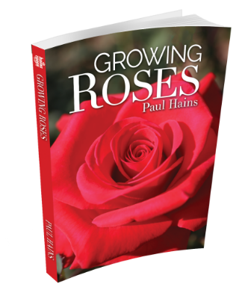

ORDER FORM
“Growing Roses”

Written by Paul Hains
Vice President, World Federation of Rose Societies
Editor, National Rose Society of Australia Inc

FULL NAME:
CONTACT PHONE:
POSTAL ADDRESS:
EMAIL:
Payment method (please tick) Cheque Cash Money Order Bank Transfer

 | Per Copy | Quantity | Total
Rose Society Members | $30
Non-Members | $35
Postage within Australia | $6
Total Cost of your Order
Bank Transfer Information
BSB : 012-429
Acc No: 2784 41863
Note: Write your name in the box on the screen
Make cheques or money orders, EFT payable to
The Rose Society of NSW Inc
Post payment with this form to
The Secretary PO Box 637 Dapto NSW 2530
Any book may be collected after payment by arrangement – e.g. at Rose Shows

NO PHONE ORDERS WILL BE TAKEN. Payment must accompany the order or be by bank transfer at the time of sending the order through. If paying by bank transfer this form may be emailed to carolmcveigh@bigpond.com with receipt details of EFT

